**Construction Logistics Planning**

**Foundation Training Delegate Workbook**

**CLP Foundation Training**

Delivered by CLOCS and HS2

Last updated November 2021 (version 2.4)

Contents

Introduction 1

Aims 2

Course programme 3

Course objectives 4

Stakeholder benefits (Task #1) 5

The impact of growth (Task #2) 6

The importance of construction logistics (Task #3) 7

Different logistics for different phases (Task #4) 8

CLP content, what’s changed? (Task #5) 9

CLP content – the new format 10

CLPs through the planning process 11

Roles and responsibilities (Task #6) 12

The potential for collaboration (Task #7) 13

Case studies of effective collaboration 14

Effective collaboration (Task #8) 15

Your experience of planned measures (Task #9) 16

What can you do differently? (Task #10) 17

CLP process (Task #11) 18

Best practice review (Task #12) 19

Reflections 20

Next step, CLP Practitioner Course 21

# Introduction

Welcome to the Construction Logistics Planning Foundation workshop. This course has been developed by CLOCS in conjunction with TfL and HS2, and introduces logistics planning and explains the benefits of a consistent and collaborative approach to this vital element of the construction process.

This workbook includes the course programme and various tasks that are covered over the course. Each task contains editable fields so that you can make notes directly into the workbook for future reference. All delegates will be provided with a copy of the presentation after the course.

Delegates are also provided with an Outline CLP template and an example CLP case study, both of which are used in one of the later tasks

# Aims

The aim of the CLP Foundation Training course is to:

* Simplify and standardise CLP presentation, structure and compilation across the industry
* Enhance awareness of the importance and benefits of CLPs
* Introduce you to the CLP format and guidance – to ensure you are prepared for its roll-out and requirements from now

This training will equip you to:

* Understand the CLP requirements and their relevance to you
* Understand the context of freight and construction
* Understand the complexity of construction and construction logistics
* Recognise the purpose of CLPs and the benefits they offer
* Summarise the CLP planning process
* Appreciate the different roles of those involved in the production and approval of CLPs
* Understand the CLP structure and content
* Explore opportunities for CLP Planned Measures
* Describe the standardised approach to developing a CLP

# Course programme

**Day 1 (09:10 to 13:15)**

|  |  |  |
| --- | --- | --- |
| **Timing** | **Duration** | **Content** |
| 09:10 - 10:00 | 50 mins | Open session & networking | Introduction |
| 10:00 – 10:50 | 50 mins | Icebreaker – personal objectives |
| 10:50 – 11:20 | 30 mins | Lesson 1 – Freight in London & Cites – The Big Picture |
| *11:20 – 11:35* | *15 mins* | *Break* |
| 11:35 – 12:35 | 60 mins | Lesson 2 – Construction Logistics: What is it? Why is it important? |
| 12:35 – 13:15 | 40 mins | Lesson 3 – CLPs |

**Day 2 (09:10 to 13:15)**

|  |  |  |
| --- | --- | --- |
| **Timing** | **Duration** | **Content** |
| 09:10 – 09:35 | 25 mins | Lesson 4 – The Planning Process: How do CLPs fit in? |
| 09:35 – 10:15 | 40 mins | Lesson 5 – Your Role in the CLP Process |
| 10:15 – 10:55 | 40 mins | Lesson 6 – CLP structure |
| *10:55 – 11:10* | *15 mins* | *Break* |
| 11:10 – 11:50 | 40 mins | Lesson 7 – Making the most of CLPs: Planned Measures |
| 11:50 – 12:50 | 60 mins | Lesson 8 – The CLP Step-by-step Process |
| 12:50 – 13:15 | 25 mins | Reflections | Summary | Quiz | Evaluation |

# Course objectives

Key thing that I would like to take away from today’s training

|  |
| --- |
|  |

# Stakeholder benefits (Task #1)

How do CLPs benefit these stakeholders?

|  |
| --- |
| **Developers** |
| **Contractors** |
| **Suppliers** |
| **Planners** |
| **Community** |

# The impact of growth (Task #2)

Consider opportunities and challenges this changing landscape might bring to:

|  |
| --- |
| **Congestion** |
| **Construction and freight industries** |
| **Residents** |

# The importance of construction logistics (Task #3)

Can you think of any examples from your own experience of when good construction logistics was critical?

|  |
| --- |
|  |

# Different logistics for different phases (Task #4)

How do logistics requirements change through construction?

* What types of materials are coming on and off site?
* What types of vehicles/modes of transport might be used?
* Who might be working on the site, what will the site physically be like at each stage?

|  |  |
| --- | --- |
| Demolition |  |
| Excavation |  |
| Sub-structure |  |
| Super-structure |  |
| Cladding |  |
| Fit-out and commissioning |  |

# CLP content, what’s changed? (Task #5)

What do you think should be included in a best practice CLP?

|  |
| --- |
|  |

Of these, which in your experience is most often overlooked?

|  |
| --- |
|  |

# CLPs through the planning process

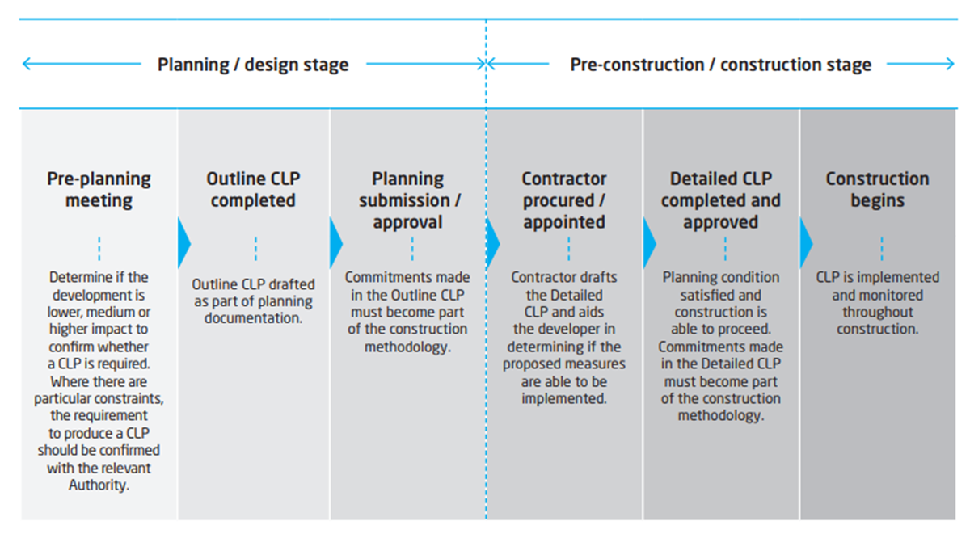

# Roles and responsibilities (Task #6)

Who is involved in developing and delivering CLPs?

|  |
| --- |
|  |

Who is ultimately responsible for each CLP? Is anyone…?

|  |
| --- |
|  |

Should anyone else be involved?

|  |
| --- |
|  |

# The potential for collaboration (Task #7)

Thinking about the stakeholders you have just listed, how could these stakeholders, and anyone else you think should be involved, collaborate to better develop and implement CLPs?

|  |
| --- |
|  |

What could the benefit of this collaboration be?

|  |
| --- |
|  |

# Case studies of effective collaboration

**Berkeley Group**

The Berkeley Group have a number of residential developments in London and the South of England. Made up of St George, St James, Berkeley, St Edward and St William, the Berkeley Group focuses on enabling construction and marketing to start as early as possible in the development cycle.

The Berkeley Group use their trusted contractors to engage with architects during planning on all projects. This then informs their designs and ensures their schemes are phased considering how the development will be built.

Input from the contractor is integrated into the design of the development and the creation of the outline CLP before planning, while there is still flexibility to consider changes.

Having construction logistics knowledge applied to the design, planning and phasing enables a smoother planning process, more efficient construction programme and fewer impacts. Contractor input is fed in at an early stage into the Outline CLP document for a more accurate and feasible plan.

**Nine Elms Construction Charter**

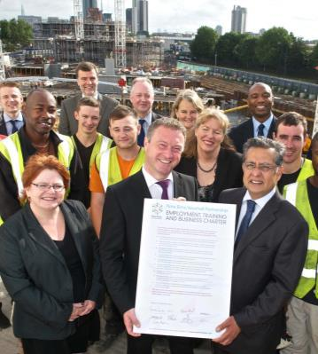Nine Elms on the South Bank has a number of regeneration developments such as the new US embassy, Battersea Power Station, new areas of public realm, 18,000 new homes, and two new underground stations. Major developers, Wandsworth and Lambeth Councils, and TfL signed up to a Construction Charter providing a collaborative code of construction practice.

The Charter was developed with all partners and endorsed by the Considerate Constructors Scheme. It sets out how stakeholders will collaborate to effectively plan and manage their sites, and their impact on surrounding developments and communities.

The responsibilities and requirements of developers and contractors are outlined with the aim of mitigating adverse effects on highway safety and movement, public health and the environment, access for local residents and businesses, the local economy and the general travelling public and visitors.

Construction logistics collaboration between neighbouring projects has many benefits for both contractors and stakeholders.

# Effective collaboration (Task #8)

Reflecting on the activities you have just completed and the two case studies you have read, what will you do differently to ensure you achieve effective collaborative working on your current and/or future projects?

Can you set any SMART (specific, measurable, attainable, results-oriented, time-bound) objectives?

|  |
| --- |
|  |

What could the benefit of this collaboration be?

|  |
| --- |
|  |

# CLP content – the new format

|  |  |  |
| --- | --- | --- |
| **Section** | **Heading** | **Level of detail** |
| 1 | Introduction | 2 -3 pages |
| 2 | Context, considerations and challenges | 4-5 pages |
| 3 | Construction programme and methodology | 2 -3 pages |
| 4 | Vehicle routing and site access | 4-5 pages |
| 5 | Strategies to reduce impact | 4-5 pages |
| 6 | Estimated vehicle movements | 1-2 pages |
| 7 | Implementing, monitoring and updating  *(detailed CLP only)* | 1-2 pages |

# Your experience of planned measures (Task #9)

What planned measures can be used to enhance a development’s logistics process and reduce negative impact?

|  |
| --- |
|  |

What innovative approaches have you implemented, approved or witnessed?

|  |
| --- |
|  |

# What can you do differently? (Task #10)

Thinking about a current or recent construction project you’ve worked on, what planned measures could you have introduced or recommended to benefit the project?

|  |
| --- |
|  |

Why did you not introduce these?

|  |
| --- |
|  |

What will you do differently in the future?

|  |
| --- |
|  |

# CLP process (Task #11)

Please refer back to page 10 in this pack to see the CLP process.

How do you currently do it and who is involved?

|  |
| --- |
|  |

How will you do it going forward and who should be involved?

|  |
| --- |
|  |

# Best practice review (Task #12)

Please review the Outline CLP template and the Cannon Street case study, provided as separate documents.

Once you have read through and reviewed the CLP, consider what has been done well in the CLP and its content, e.g. planned measures, detailed information, collaboration etc.?

|  |
| --- |
|  |

What further benefits could have been reaped through this CLP?

|  |
| --- |
|  |

What would you do differently if you were working on this CLP?

|  |
| --- |
|  |

# Reflections

What will you do differently as a result of this training?

|  |
| --- |
|  |

What would you want to do differently but don’t think is feasible in your work? Why? What are the constraints?

|  |
| --- |
|  |

Who, if anyone, will you share your learning with from this training?

|  |
| --- |
|  |

# Next step, CLP Practitioner course

The CLP Practitioner training course expands on your learning today and provides delegates with more in-depth and practically applied knowledge and skills.

The course provides you with hands on practice and equips you to:

* Complete the various sections of the CLP
* Understand the CLP review stages
* Acknowledge how the CLP may be tailored to align with the 6 phases of construction
* Utilise CLP vehicle estimation methods
* Implement planning measures through CLP development
* Understand how to review and re-assess the CLP
* Justify and implement changes to CLPs

If you would like to book onto the CLP Practitioner course, please visit the CLOCS website at <https://www.clocs.org.uk/page/CLPtraining>.