# Outline CLP Template

|  |  |
| --- | --- |
| **Development name:** |  |
| **Landowner:** |  |
| **Site address:** |  |
| **Site postcode:** |  |
| **Existing site use:** |  |
| **Summary of works:** |  |

|  |  |  |  |
| --- | --- | --- | --- |
| **Construction Logistics Manager:** | |  | |
| Phone number: | |  | |
| Email: | |  | |
| **Logistics provider contact name:** | |  | |
| Phone number: | |  | |
| Email: | |  | |
| **CLP Produced by:** |  | |  |
| Name | Signature | | Date |
|  |  | |  |
|  | CLP Accreditation date: | |  |
| **CLP reviewed by:** |  | |  |
| Name | Signature | | Date |
|  |  | |  |
|  | CLP Accreditation date: | |  |

**1 INTRODUCTION**

**1.1 CLP OBJECTIVES**

This section should set out the objectives of the CLP, such as reduced vehicles or lower associated emissions.

**1.2 SITE CONTEXT**

Description of the site location outlining local authorities, nearby highway and transport links and any relevant contextual information.

**1.3 DEVELOPMENT PROPOSAL**

Outline a proposed demolition and build, including unit numbers and size.

**1.4 CLP STRUCTURE**

Table of contents and figures.

**2 CONTEXT, CONSIDERATIONS AND CHALLENGES**

**2.1 POLICY CONTEXT**

Outline any relevant policies, such as The Traffic Management Plan (2004), London Plan (2011), etc.

**2.2 THREE PLANS AT DIFFERENT SCALES**

To include the following plans:

* Regional plan with a scale smaller than 1:15,000) showing:
* The location of the work site(s) in the context of main roads, routes, water ways, railways and other key infrastructure
* Freight delivery infrastructure (e.g. consolidation centres)
* Community considerations.
* Local context plan with a scale of between 1:2,000 and 1:3,000) showing:
* The location of the site in the context of surrounding roads, footways, cycle routes and other infrastructure
* Detail nearest wharf and railhead to site
* Potential marshalling areas
* Freight delivery infrastructure (e.g. consolidation centres)
* Community considerations.
* Site boundary plan with a scale of between 1:500 and 1:1,000 showing:
* The local context of the area with a fine level of detail (OS data) as currently provisioned highlighting the extent of footways, other buildings, cycle lanes and even road markings.
* Community Considerations

**2.3 LOCAL ACCESS INCLUDING HIGHWAY, PUBLIC TRANSPORT, CYCLING, WALKING AND WATERWAYS**

2.3.1. HIGHWAYS, CARRIAGEWAYS AND FOOTWAYS

Describe any adjacent highways, carriageways and footways or nearby roadways requiring extra attention, such as red routes. Include proposed Traffic Regulation Orders (TROs) required during any stage of construction.

2.3.2. RAILWAY/UNDERGROUND

Describe nearby running lines and any necessary precautions to prevent disruption.

2.3.3. BUS ROUTES

Describe nearby bus routes and any necessary precautions to prevent disruption.

2.3.4. CYCLING

Describe nearby cycle routes or hubs and any necessary precautions to prevent disruption.

2.3.5 WATERWAYS

Describe nearby water routes, and any necessary precautions to prevent disruption.

**2.4 COMMUNITY CONSIDERATIONS**

2.4.1. LOCAL POLICY

Outline any relevant local policy, such as a local authority code of construction practice.

2.4.2. EXAMPLE: SCHOOLS, HOSPITAL

Detail any nearby notable building uses that require special attention and propose mitigation strategies.

**3 CONSTRUCTION PROGRAMME AND METHODOLOGY**

The charts in this section are to be made using the construction logistics planning tool contained in the CLP Guidance. The following are example outputs from the spreadsheet.

Provide a high-level description of the construction OR infrastructure programme and include tables generated through the linked tool.

The below examples are for a construction programme.

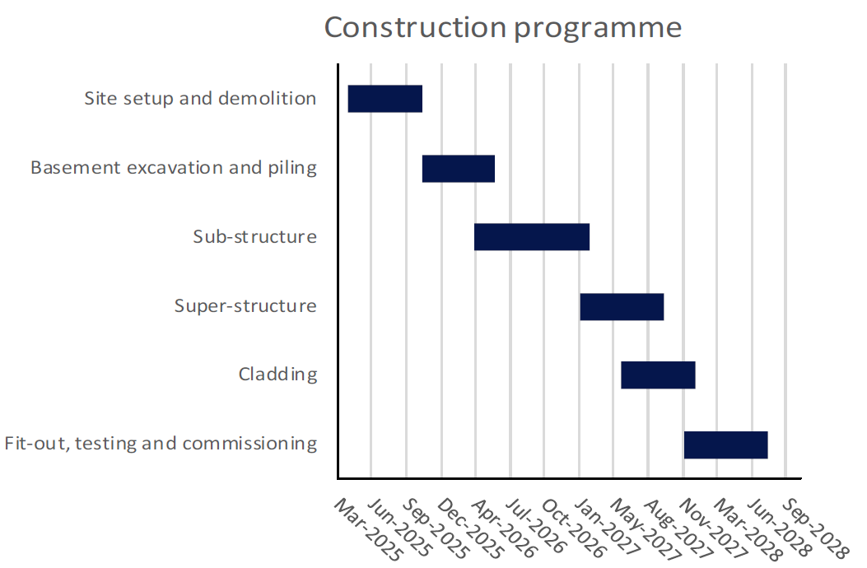

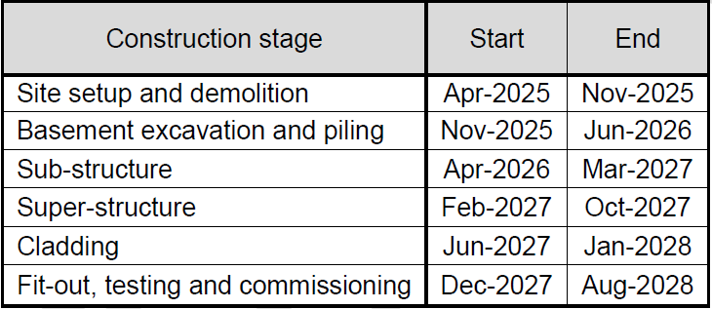

**3.1 CONSTRUCTION PROGRAMME PHASES**

3.1.1. SITE SETUP AND DEMOLITION

Outline setup and demolition phase, including timings, plant and vehicles required and works description.

3.1.2. BASEMENT EXCAVATION AND PILING

Outline basement excavation and piling phase, including timings, plant and vehicles required and works description.

3.1.3. SUB-STRUCTURE

Outline sub-structure phase, including timings, plant and vehicles required and works description.

3.1.4. SUPER-STRUCTURE

Outline super-structure phase, including timings, plant and vehicles required and works description.

3.1.5. CLADDING

Outline cladding phase, including timings, plant and vehicles required and works description.

3.1.6. FIT-OUT, TESTING AND COMMISSIONING

Outline fit-out, testing and commissioning phase, including timings, plant and vehicles required and works description.

**3.2 INFRASTRUCTURE PROGRAMME PHASES**

3.2.1. SITE ESTABLISHMENT, CLEARANCE AND ALTERATIONS

Includes establishing welfare accommodation, clearing the site of debris and existing buildings and alterations to existing infrastructure (e.g. utilities).

3.2.2. EXCAVATION AND FOUNDATIONS

Typically includes removing excavated material from the site and excavating the basement. As the basement is being dug, piling is required to form the basement walls and structural footings.

3.2.3. SUB-STRUCTURE

Below ground works include foundations and basement walls. Plant installation can also occur.

3.2.4. SUPER-STRUCTURE

Includes the above ground structural elements of the infrastructure.

3.2.5. SERVICES AND SYSTEMS INSTALLATION

Infrastructure projects typically have extensive and complex systems. These can include mechanical, electrical and plumbing (MEP) systems, but also specialised systems (e.g. signalling, electrical and water).

3.2.6. FIT-OUT, TESTING AND COMMISSIONING

Includes all mechanical, electrical, and plumbing installation and testing of newly installed systems.

**4 VEHICLE ROUTING AND SITE ACCESS**

To include the following plans:

* Regional plan with a scale smaller than 1:15,000 showing:
* Strategic roads that are likely to be used to access the site.
* Freight delivery infrastructure (e.g. consolidation centres)
* Local plan with a scale of between 1:2,000 and 1:3,000 showing:
* Local area routing including turn back routes
* Local access roads may be required to be used for the last stages of a journey to site. Specific access routes on the local roads should be identified. The connection to/from local roads to the strategic road network should also be shown
* Routes that are off-limits to site traffic
* Detail nearest wharf and railhead to site
* Freight delivery infrastructure (e.g. consolidation centres)
* Community Considerations

Medium impact sites require a single plan at this scale showing the typical site layout.

Higher impact sites require multiple plans at this scale showing the site layout during the different phases of construction.

* Site plan with a scale of between 1:500 and 1:1,000 showing:
* Local access to the site
* Hoarding lines with access gates (vehicle, pedestrian and cyclist)
* Pedestrian and cycle access and routes both into and on site
* Highway changes (including footway and road closures)
* Vehicle routing to site (including swept paths)
* Vehicle pit lanes, marshalling and loading areas
* Vehicle routing on to and within the site (including swept paths)
* Crane location(s)
* Potential areas of conflict and traffic marshal locations
* Parking (vehicle and cycle), loading and unloading arrangements.
* Community Considerations

**5 STRATEGIES TO REDUCE IMPACTS**

[Delete Medium/Higher Impact Planned Measures Checklist as required]

|  |  |  |  |
| --- | --- | --- | --- |
| Medium Impact Site Planned Measures Checklist | Committed | Proposed | Considered |
| Measures influencing construction vehicles and deliveries |  |  |  |
| Safety and environmental standards and programmes |  |  |  |
| Adherence to designated routes |  |  |  |
| Delivery scheduling |  |  |  |
| Re-timing for out of peak deliveries |  |  |  |
| Re-timing for out of hours deliveries |  |  |  |
| Use of holding areas and vehicle call off areas |  |  |  |
| Use of logistics and consolidation centres |  |  |  |
| Vehicle choice |  |  |  |
| Measures to encourage sustainable freight |  |  |  |
| Freight by water* |  |  |  |
| Freight by rail* |  |  |  |
| Material procurement measures |  |  |  |
| DfMA and offsite manufacture |  |  |  |
| Re-use of material on site |  |  |  |
| Smart procurement |  |  |  |
| Other measures |  |  |  |
| Collaboration with other sites in the area |  |  |  |
| Implement a staff travel plan |  |  |  |

* If site, consolidation centre or holding areas are within 100m of foreshore of navigable waterway or rail freight siding.

|  |  |  |  |
| --- | --- | --- | --- |
| Higher impact Site Planned Measures Checklist | Committed | Proposed | Considered |
| Measures influencing construction vehicles and deliveries |  |  |  |
| Safety and environmental standards and programmes |  |  |  |
| Adherence to designated routes |  |  |  |
| Delivery scheduling |  |  |  |
| Re-timing for out of peak deliveries |  |  |  |
| Re-timing for out of hours deliveries |  |  |  |
| Use of holding areas and vehicle call off areas |  |  |  |
| Use of logistics and consolidation centres |  |  |  |
| Vehicle choice |  |  |  |
| Measures to encourage sustainable freight |  |  |  |
| Freight by water* |  |  |  |
| Freight by rail* |  |  |  |
| Material procurement measures |  |  |  |
| DfMA and offsite manufacture |  |  |  |
| Re-use of material on site |  |  |  |
| Smart procurement |  |  |  |
| Other measures |  |  |  |
| Collaboration with other sites in the area |  |  |  |
| Implement a staff travel plan |  |  |  |

* If site, consolidation centre or holding areas are within 100m of foreshore of navigable waterway or rail freight siding.

**5.1.1. Measures influencing construction vehicles and deliveries**

Safety and environmental standards and programmes - outline measures that will be undertaken to adhere to FORS, CLOCS and other standards and programmes.

Adherence to designated routes - outline measures that will be undertaken to ensure vehicles arriving at the site location will adhere to routes designated in Section 4.

Delivery scheduling - outline the system that will be implemented to ensure deliveries to site are scheduled and recorded.

Re-timing for out of peak deliveries - outline proposals for how deliveries will be re-timed out of peak hours.

Re-timing for out of hours deliveries - outline proposals for how deliveries will be re-timed out of hours.

Use of holding and vehicle call off areas - outline a proposed strategy for use of a holding and vehicle call off area.

Use of logistics and consolidation centres - outline proposals for the use of load consolidation and a consolidation centre for both contractors and sub-contractors.

Vehicle choice – outline proposals for utilising vehicles with greater payloads to reduce vehicle movements and improve safety, efficiency and environmental impact but only if those vehicles meet the highest environmental and safety standards.

**5.1.2. MEASURES TO ENCOURAGE SUSTAINABLE FREIGHT**

Freight by Water (if site, consolidation centre or holding areas are within 100m of foreshore of navigable waterway) - outline the feasibility of delivering to site by water.

Freight by Rail - outline the feasibility of delivering to site by rail.

**5.1.3. MATERIAL PROCUREMENT MEASURES**

DfMA and off-site manufacture - outline proposals for the use of pre-fabrication and off-site manufacturing of construction material.

Re-use of material on site - outline proposals for re-using material on site.

Smart procurement - identify suppliers who have been recognised to implement measures in line with the CLP’s objectives, such as reducing vehicle movements.

**5.1.4. OTHER MEASURES**

Collaboration with other sites in the area - outline proposed opportunities to collaborate with neighbouring construction sites, such as sharing holding areas.

Implement a staff travel plan - outline the staff travel plan for staff and workers travelling to site.

**6 ESTIMATED VEHICLE MOVEMENTS**

The charts in this section are to be made using the construction logistics planning tool contained in the CLP Guidance. The following are example outputs from the spreadsheet of a **construction programme**. If your CLP is about an infrastructure programme, your outputs will have different stages.

ESTIMATED CONSTRUCTION VEHICLES – MONTHLY AND DAILY

|  |  |  |  |
| --- | --- | --- | --- |
| Construction Stage | Period of stage | No. of trips (monthly) | Peak no. of trips (daily) |
| Site setup and demolition |  |  |  |
| Basement excavation and piling |  |  |  |
| Sub-structure |  |  |  |
| Super-structure |  |  |  |
| Cladding |  |  |  |
| Fit-out, testing and commissioning |  |  |  |
| Peak period of construction |  |  |  |

ESTIMATED CONSTRUCTION VEHICLES – MONTHLY AND DAILY

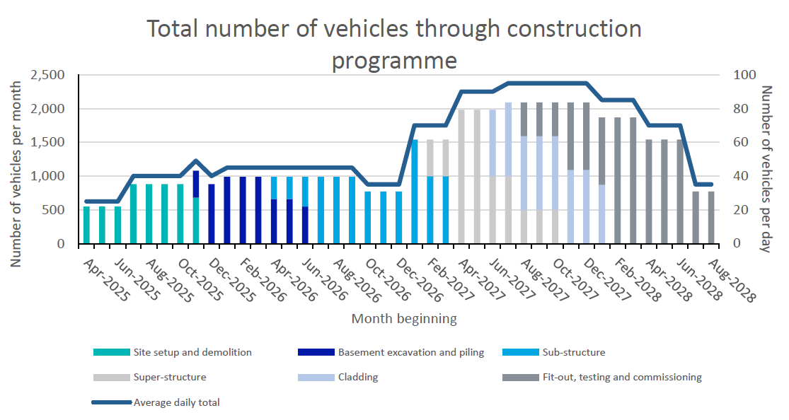

NUMBER AND VEHICLE TYPE BY PHASE OF CONSTRUCTION

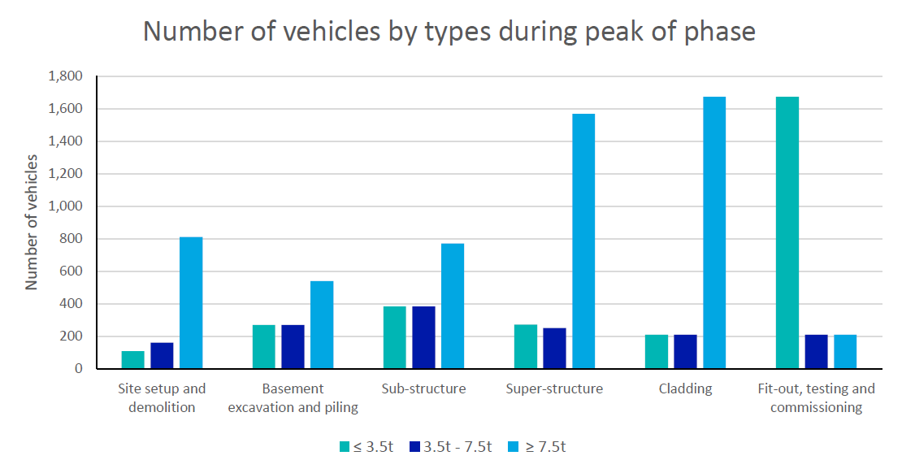

HOURLY ARRIVAL PROFILE OF VEHICLES DURING PEAK

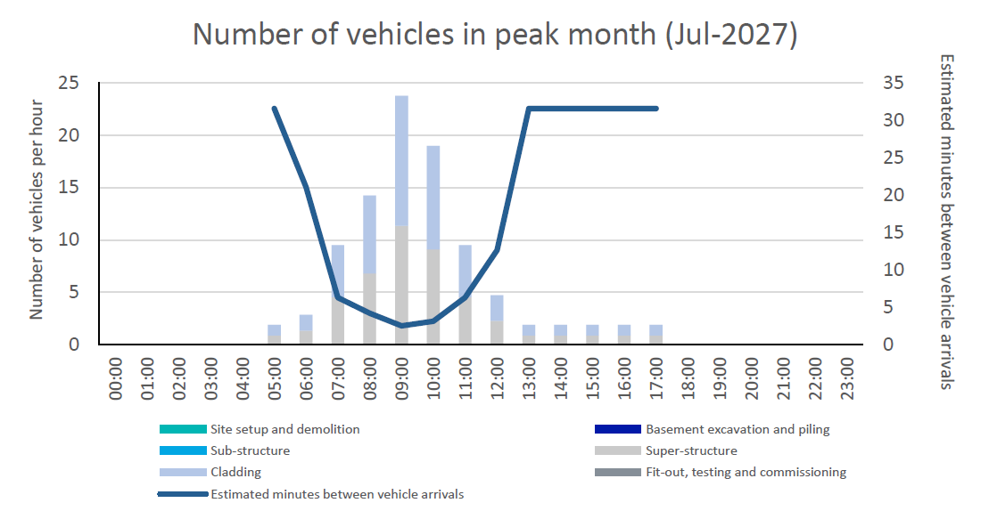

**7 IMPLEMENTING, MONITORING AND UPDATING**

Describe a proposed system for implementing the Outline CLP on site, and how this will be monitored regularly and updated. The Detailed CLP will require a far more detailed description once a contractor has been appointed.